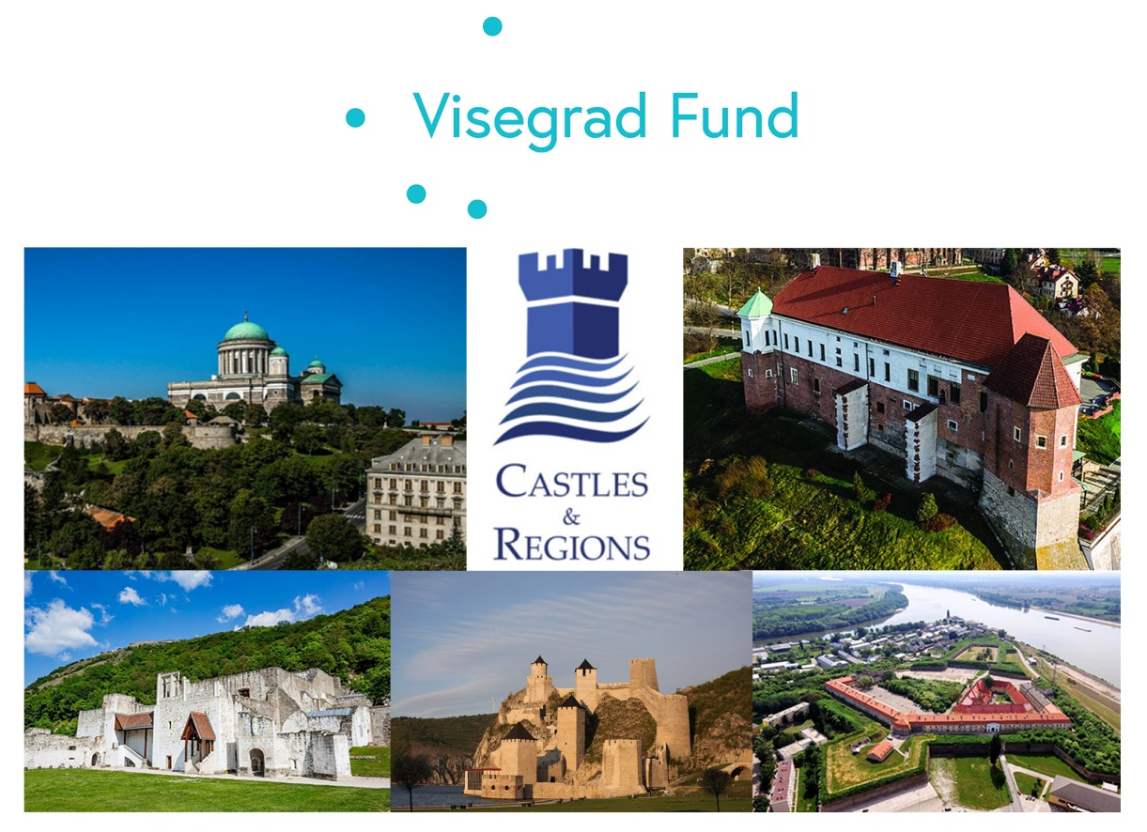

"CASTLE FOR THE REGION - REGION FOR THE CASTLE"
SEMINAR
14 October, 2021
Sandomierz
Agenda
(with real or online presence)
TOPICS:
- RENEWAL OF THE ROLE OF MIDDLE AND MODERN AGE CASTLE IN EDUCATION, TOURISM AND REGIONAL PRODUCT/ECONOMY PROMOTION THROUGH COOPERATION BETWEEN CASTLE AND ITS REGION

- NETWORK OF CASTLES ALONG THE DANUBE / VISTULA RIVER

PROGRAMME:
11:00 Registration and participants get some information materials (of study, WS programme, World Café process, partners – optionally prospects, etc.)
Show of
- “Our Common Past & Common Future” Virtual Exhibition
Refreshments

FIRST PART:
11:30 Welcome words
Speeches
- “Historical connection of local castle/fortress to the region and further” -
dr Mikołaj Getka-Kenig, District Museum in Sandomierz
- “Some words about the network of middle/modern age castles and their partners / Introduce the Supported Project and the Lead Partner”
Gábor Rezi-Kató, acting vice director, Hungarian National Museum
- “Keynotes and Summaries of TOPICS”
István Szilvássy, president, Association of Hungarian Settlements’ and Regions’ Developers
- “The Sandomierz Wine Tradition“
Magdalena Kapłan, PhD, University of Life Sciences in Lublin, Faculty of Horticulture and Landscape Architecture, on behalf of the Sandomierz Vintners' Association,.
- “Richness of regional products of Sandomierz land”
Katarzyna Batko, Director of Local Tourist Organization "Partnership of Sandomierz Land"
- “The role of Sandomierz castle for the region - current state and challenges” Wojciech Dumin, Director of the Sandomierz Cultural Center

Translator:
- Agnieszka Białousz - Polish-English
- Magdalena Garbacik - Hungarian-Polish
13:00 Lunch
SECOND PART: What Needs To Do?
Structured conversational process by the World Café session (interactive exchange of views, brainstorming on the previously mentioned topics) See http://www.theworldcafe.com/

14:00 Moderator – Waldemar Białousz
Introduction to the World Café Process and Topics of the World Café:
- Castle as an immanence part of formal education and local identity building,
- Castle as a center for promotion of regional economy and tourist services,
- Cooperation and contacts between castles/museums/partners,

Participants add comments, questions to the topics on tags (to online see the web: https://en.linoit.com/) and choose/sign table hosts. Organizing participants to round tables.(Coming 5 rounds to topics)

14:20 Round table brainstorming rounds the First
14:40 Round table brainstorming rounds the Second
15:00 Round table brainstorming rounds the Third
15:20 Round table brainstorming rounds the Forth
15:40 Round table brainstorming rounds the Fifth

16:00 What will happen? Networking, Memorandum, Next steps
- Mikołaj Getka-Kenig, District Museum in Sandomierz
- István Szilvássy responsible for the content of the project - president, Association of Hungarian Settlements’ and Regions’ Developers

16:20 Summaries of Round table work by table hosts
17:00 Round table: Comments by representatives of state, regional, local decision-makers and
17:30 Closing word by local project partner

The project is co-financed by the Governments of Czechia, Hungary, Poland and Slovakia through Visegrad Grants from International Visegrad Fund. The mission of the fund is to advance ideas for sustainable regional cooperation in Central Europe.

